Incubator controller with Bluetooth

# What is it?

This is digital incubator controller module with Bluetooth and dedicated Android application. It has following features:

* + - * Temperature regulation using one of three methods: on/off control, proportional-integral (PI) control by heater power variation and hybrid control.
      * Humidity regulation using simple on/off control.
      * Timer for automatic rotation of eggs.
      * Heater is driven by phase controlled dimmer.
      * Automatic PI controller tuning implemented in Android application.
      * Buzzer controlled by configurable protection limits for temperature and humidity.
      * Three configurable 120V TRIAC outputs, which are galvanically isolated from control side.
      * Modbus protocol over Bluetooth, i.e. device potentially can be integrated into larger automation system.

Device specification:

|  |  |
| --- | --- |
| Parameter | Value |
| Control power supply voltage | 5V-20V |
| Control power consumption | 60mA at 5V input |
| Commutated AC mains | 120V 60Hz |
| Output power per channel | 100W (300W with heatsink) |
| Temperature range | 5 °C … 60 °C |
| Humidity range | 20 % … 80 % |
| Temperature resolution | 0.01 °C |
| Temperature accuracy | ± 0.3 °C |
| Humidity resolution | 0.04 % |
| Humidity accuracy | ± 2 % |
| PCB size | 40 mm x 56.5 mm (1.57 x 2.22 inch) |

Notes:

* Temperature and humidity ranges are defined by measurements accuracy, for more information check the HTU21D datasheet.
* Control power should be provided externally, see the wiring diagram below.

Device internals:

|  |  |
| --- | --- |
|  | Part number |
| Temperature sensor | HTU21D |
| Microcontroller | STM32F030K6T6 |
| TRIAC | BTA08-600CWRG |
| Bluetooth module | HC-05 |

Board connections:

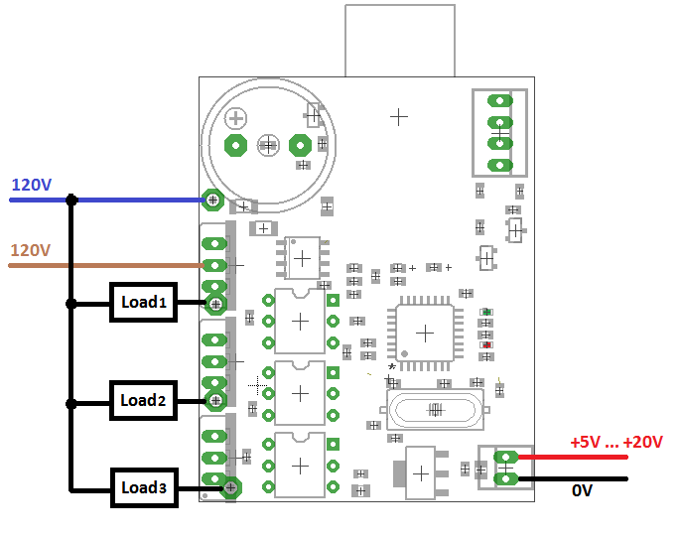

There are no fuses on board, it is recommended to place at least one common fuse before the device.

LEDs:

* Green: power on, also toggling every time during temperature measurements and Bluetooth request.
* Red: fault indication (on in case when temperature sensor fault occurred at least once).

# Install of Android application

## To install application:

1. Download **IncubatorApplication.apk** and copy it to your smartphone.

<https://github.com/akpc806a/Bluetooth_incubator/raw/master/Mobile/IncubatorApplication.apk>

1. Go to menu > Settings > Security > and check Unknown Sources to allow your phone to install apps from sources other than the Google Play Store.
2. Tap IncubatorApplication.apk file in File Manager. Then hit Install.
3. Allow access for application to Bluetooth network and paired devices.

## First launch of application:

1. Turn on the incubator controller. Make sure that green LED is blinking.
2. Open phone Settings menu.
3. Under "Wireless & networks," tap Bluetooth.
4. Make sure Bluetooth is turned on.
5. Your device will scan for and display all available Bluetooth devices in range under "Available devices." If your Bluetooth device isn't showing in the list, tap more More and then Refresh.
6. Tap the **HC-05** in the list of the Bluetooth devices. This is Bluetooth name of incubator controller.
7. Follow the on-screen steps. If the pairing is successful, your phone or tablet connects to the device.
8. If you're asked to enter a passcode - use **1234**. 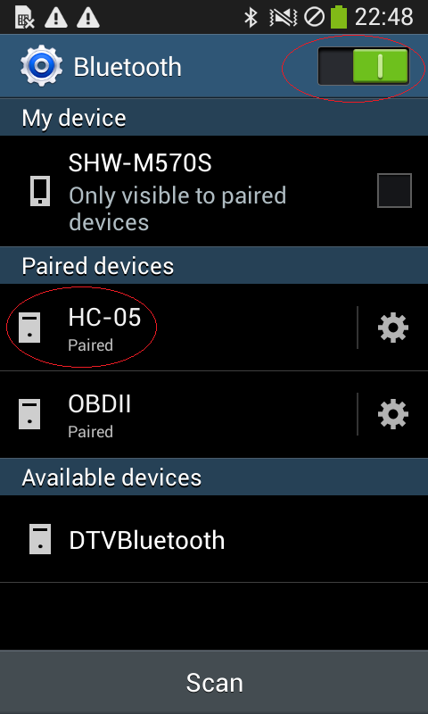
9. Run IncubatorApplication application.

# Android application short user guide

## Connection page

Tap drop-down list and select HC-05 as Bluetooth device. It will initiate the connection to hardware.

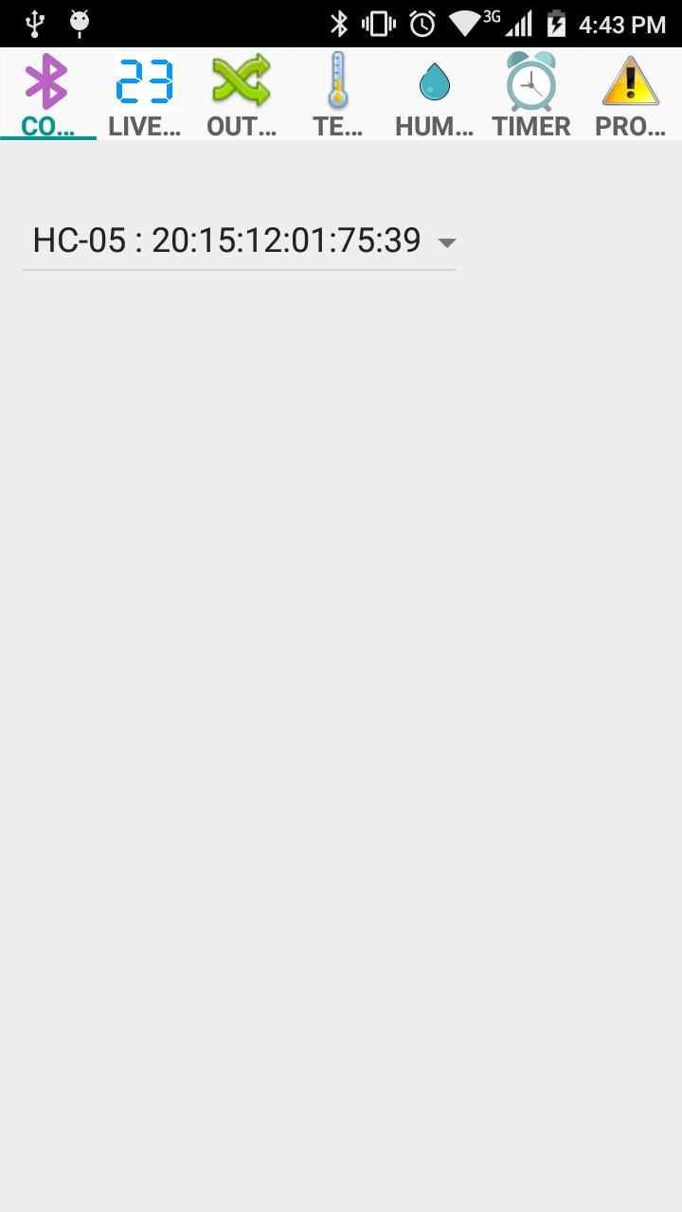

Always turn on the Bluetooth in your phone before launching the incubator application.

If you forgot to turn on the Bluetooth, turn it on and then restart the application.

## Live data page

This page displays the actual temperature, humidity value and timer clock. The right column is the states of corresponding outputs: for temperature this is power of heater from 0 to 100 (%), for humidity and timer it is On or Off.

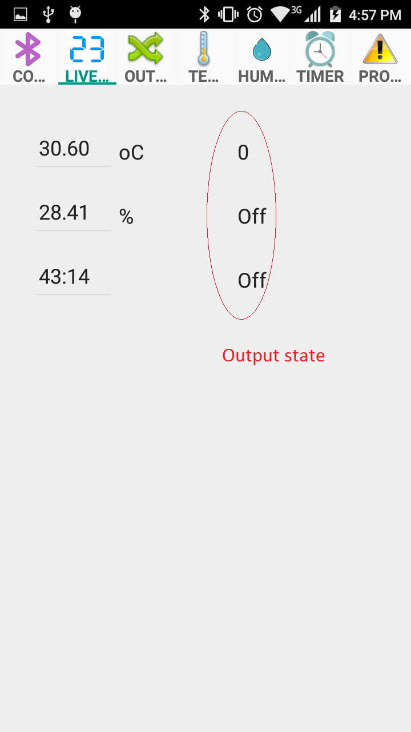

## Output routing page

The device has 3 independent outputs: Output 1, Output 2, Output 3. Each output can be driven from temperature controller, humidity controller or timer. It is also possible to assign several outputs to the same source (for example temperature controller) to provide some system redundancy.

Tap the drop-down list to select the source for corresponding output.

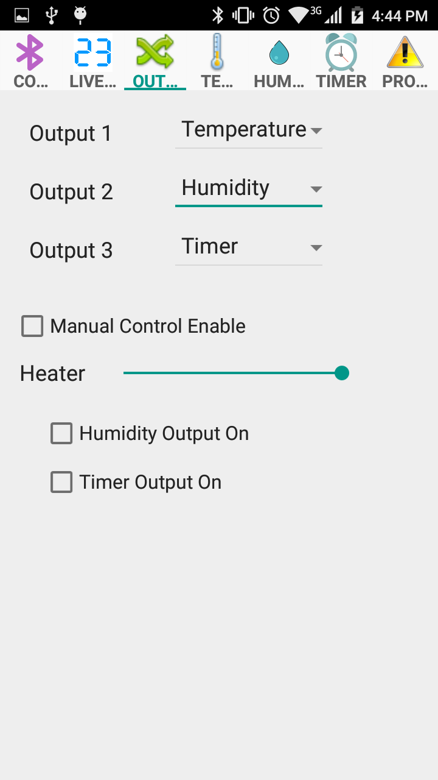

The manual mode is for testing purpose and useful to check whether heating element or light bulb is operational, as well as eggs rotation device and humidity actuator.

Tap "Manual Control Enable" to activate the manual mode. Use "Heater" slider to regulate the heater output power. Tap "Humidity Output On" to turn on the outputs assigned to humidity controller. Tap "Timer Output On" to turn on the outputs assigned to timer controller.

## Temperature page

Three types of temperature controllers are implemented:

* On/Off control. The heater will be turned off if the temperature becomes higher than "Setpoint" value plus "On-Off Hysteresis" value. The heater will be turned on if the temperature becomes lower than "Setpoint" value minus "On-Off Hysteresis" value.
* PI control. This is advanced feedback control method that smoothly regulates the heater output power to match the specified Setpoint temperature.
* Hybrid method. The hybrid method combines the best properties of On/Off and PI controls: the fastest response of On/Off controller and smooth adjustment of heater power near the temperature setpoint. If the temperature is near the setpoint with tolerance defined by hysteresis value, then the PI controller is applied. If the temperature is outside the hysteresis tolerance, then On/Off controller will be applied for several cycles. After this, the initial conditions for PI controller will be calculated and PI controller will be activated.

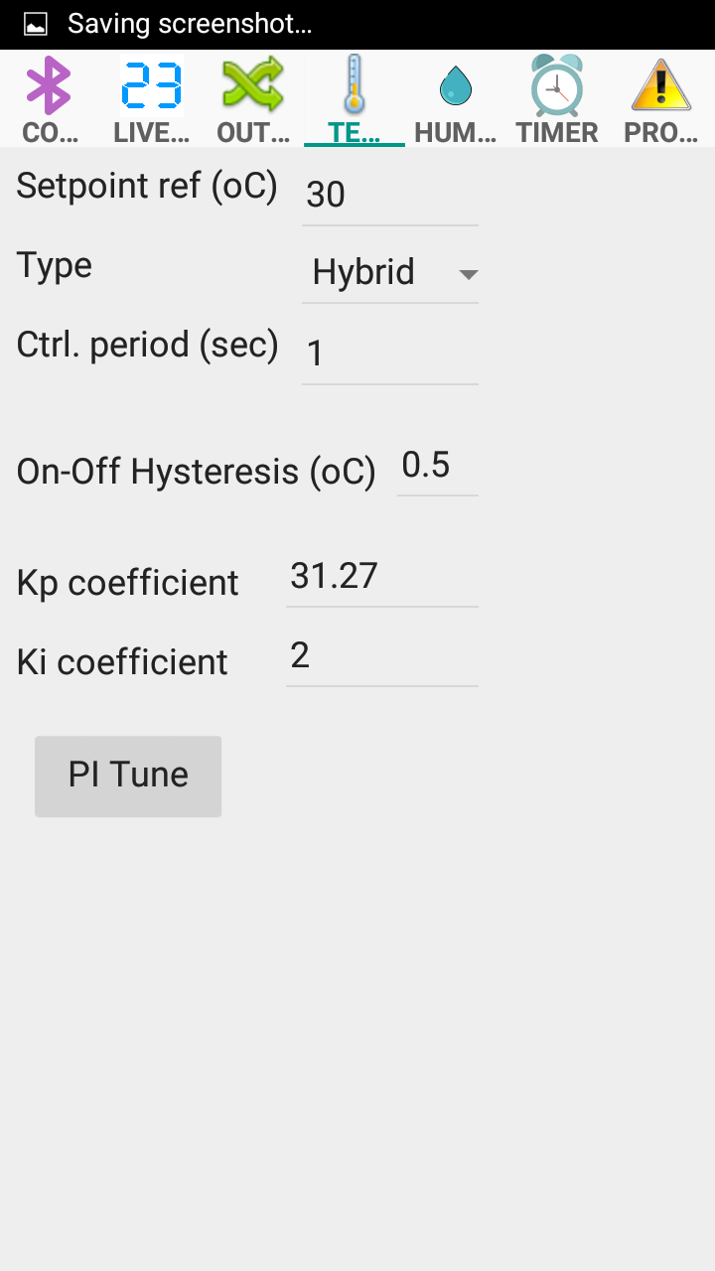

Here is comparison of temperature responses of different regulator types for 30 °C setpoint: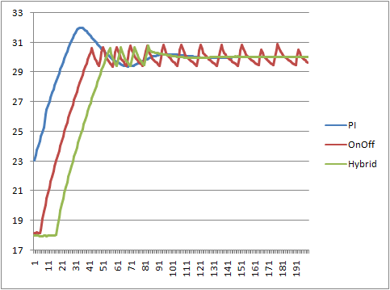

(please note, that PI controller was not tuned in this particular test)

The "Ctrl. period" parameter determines how frequently temperature being read and control procedure applied. Minimal value is 0.1 seconds, values around or more than 1 second is for typical incubators. You can get better On/Off control results with shorter control period.

For optimal performance of PI controller it is necessary to perform its tuning for actual incubation camera and heater to determine Kp and Ki coefficients. The automatic tuning of PI controller is implemented in Android application. To perform tuning follow the procedure:

1. Please make sure that there are no eggs or other vulnerable materials inside incubator (heater will be fully powered on during procedure).
2. It is recommended to write down previous values of Kp and Ki coefficients.
3. To start tuning tap "PI Tune". The button will change to "Stop". Heater will be turned on.
4. Monitor the temperature on the Live data page.
5. If the incubator camera fully heated up and there is no considerable temperature change during long time, tap "Stop". Usually it will require from 20 to 40 minutes, depending on size of incubator and heater.
6. It is not recommended to allow temperature rise more than 50 °C for long time because it could damage the plastic materials in incubator. Please monitor temperature carefully and get ready to stop tuning.

Here is the comparison of not tuned and automatically tuned PI controller:

## Humidity page

Humidity output will be turned off if the humidity value becomes higher then specified "Upper value". The output will be turned on if the humidity value becomes lower then specified "Lower value".

The "Ctrl. period" determines how frequently temperature being read and control procedure applied

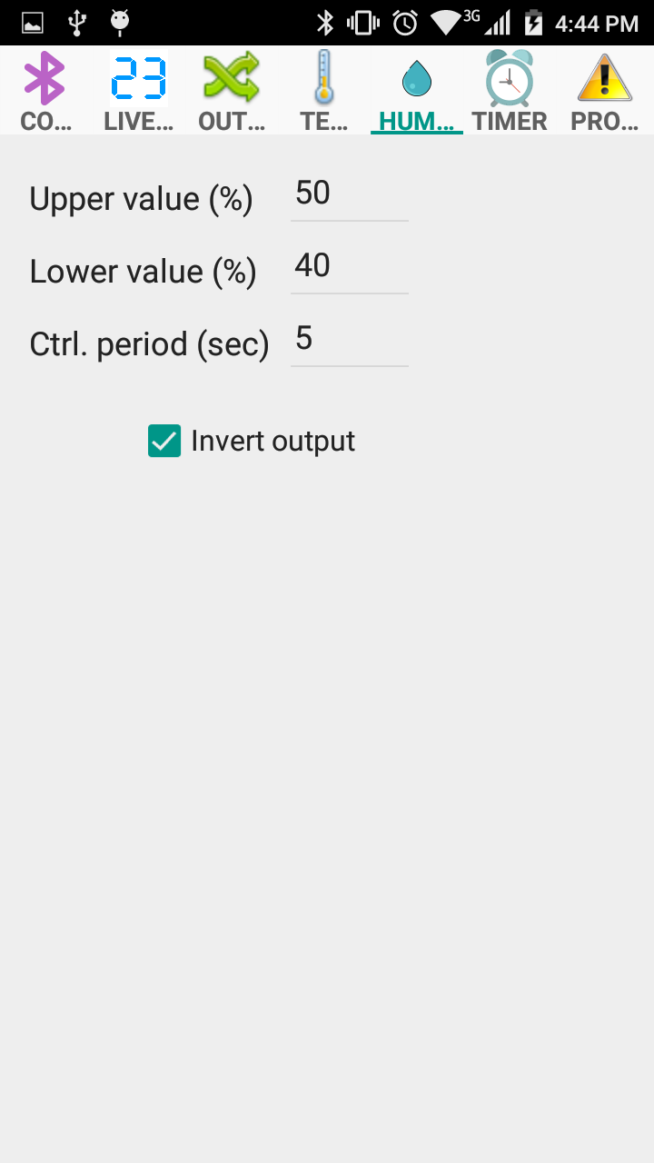

It is possible to invert the output because usually when humidity reaches some defined value the valve or actuator should be open to allow airflow into incubation camera.

## Timer page

## C:\Users\Alex\AppData\Local\Microsoft\Windows\INetCache\Content.Word\Screenshot_Page6_Timer.png

The timer for automatic rotation of eggs is controlled by two parameters: "Off interval" and "On interval". Here is timer diagram:

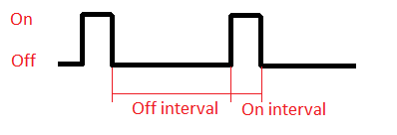

## Protection page

The protection page displays configurable parameters for indication of system failure.

If some temperature or humidity will cross the corresponding defined boundary values for specified time, the alarm will sound. To turn off the alarm one should power cycle the controller.

